□■□■□速読Ｇ単語□■□■□
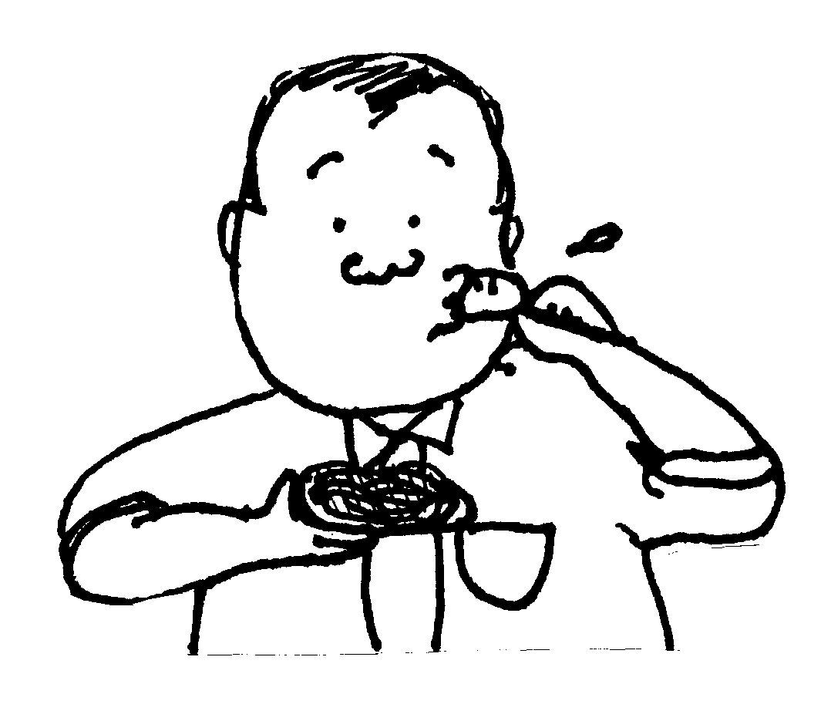
英検®準２級 273words

In 1912, Tokyo presented about 3,000 flowering cherry trees to Washington, D.C., as a symbol of friendship between Japan and the United States. The trees – which now number about 3,700 – were planted near a large pond near the Jefferson Memorial.
Last March, officers of the U.S. National Park Service found that many of these famous cherry trees had been badly damaged by beavers. The beaver is an animal about the size of a large cat that lives in rivers and ponds. It has a large, flat tail and long, sharp teeth. It uses its sharp teeth to eat through the trunks of trees. The beavers then use the trees to build homes for themselves.
The damage to the cherry trees was discovered as Park Service officers were preparing for the National Cherry Blossom Parade. This popular parade, which is held every year, includes people and performances from all over the world. The parade was held as planned, but several of the trees were in such bad condition that they had to be cut down.
The Park Service officers decided to try to catch the beavers. After a while, they caught three of the animals. The officers later set these beavers free in a wet, wooded area away from the city. Some people were worried about whether the beavers would be able to get used to the new area. Experts warned that other beavers already living in the area might attack them.
The Park Service officers came back to check on the beavers a few weeks later. They were pleased to find that the animals seemed to be living happily in their new home.

trunk:（木の）幹

1) Why did Tokyo present cherry trees to Washington, D.C.?
1, So that the number of trees would reach 3,700.
2, So that a large new pond could be created.
3, To symbolize friendship between Japan and the United States.
4, To help the beavers living near the Jefferson Memorial.

2) The beaver ( ).
1, is about the size of a small cat.
2, lives in trees near rivers and ponds.
3, uses wood from trees to build its home.
4, prefers to eat damaged trees.

3) The National Cherry Blossom Parade ( ).
1, includes people from outside the U.S.
2, is held once every ten years.
3, had beavers as a part of the parade this year.
4, was canceled because of the damage to the trees.

4) What worried some people about the beavers after they were moved?
1, Whether the beavers might damage the trees.
2, Whether the beavers might be hurt by Park Service officers.
3, Whether the beavers could get used to the new area.
4, Whether the beavers might return to Washington, D.C.

5) Which of the following statements is true?
1, The beavers are a symbol of Japanese-American friendship.
2, The damage to the trees was discovered after the parade was over.
3, National Park Service officers caught more than 10 beavers.
4, The beavers that were moved seemed happy in their new home.

